

SCH Solution for



**UT Document**

## Submitted by

## SCH Solutions Team, SCH Infotech

### Date: 01 Mar 2024

### Version: 1.0

**Document Identification**

Document Author : SCH Solutions Team, SCH Infotech Date : 01-04-2024

**Document Control**

|  |  |
| --- | --- |
| Title | UAT Document |
| Client | Emirates Steel Arkan |
| Author | SCH Solutions team |
| Date Created | 01-04-2024 |

**Version History**

|  |  |  |  |
| --- | --- | --- | --- |
| **Version No** | **Updated Date** | **Updated By** | **Reason** |
| 1.0 | 01-04-2024 | Mohan Kumar M | Inbound Shipment Invoice  SAP to SCH Assert PO deliveries update |
|  |  |  |  |
|  |  |  |  |

**Table of Contents**

1. Document Purpose 4
2. Test Script 4
3. Document Summary 8

# Document Purpose

Assert PO Inbound Deliveries will be raised through SAP Portal. The data should transfer from SAP portal to SCH and available to Inbound Shipment Invoice posting.

# Test Script

The screenshots are from SAP QA and SCH QA.

### Inbound Shipment Invoice

* + 1. Asset PO and Delivery is created in SCH.

Goto SAP Table – ME23N

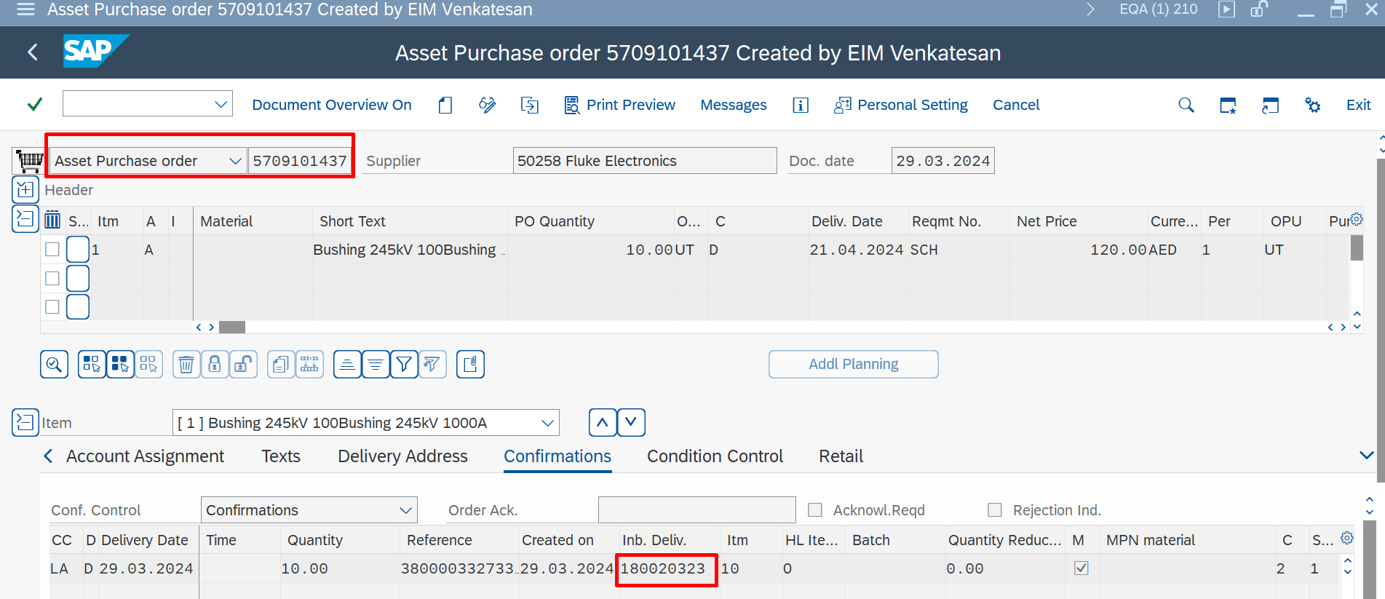

# 3. Document Summary

By using this document, Testing result for Inbound Deliveries from SAP is moved to SCH SAP T. code - ZSCH_SHIP_DEL_EXT, can be used to Process the Inbound Deliveries. Please approve the UT document to move the SAP to SCH data transfer program to PRD.

|  |  |  |  |  |  |
| --- | --- | --- | --- | --- | --- |
| **Authorized Signatories** | | | | | |
|  | | | | | |
| **Tested By** | | **Reviewed By** | | **Approved By** | |
| Name | Mohan Kumar | Name | Mohan Kumar | Name |  |
| Signature |  | Signature |  | Signature |  |
| Date | 01-04-2024 | Date |  | Date | 01.04.2024 |